**Rules of the Model**  
  
  
There are persons and viruses as a generic term called creatures.  
  
The initial population of people is fixed and cannot change.  
  
The initial population of viruses is also fixed, but can change over time/iterations.  
  
There is a two-dimensional rectangular grid with integer x, y coordinated  
  
Days/iterations represent the flow of time at different integer points in time 1-n  
  
A creature can be located at exactly one x,y coordinate at any one time.  
  
A creature has exactly one initial randomly chosen home coordinate on the grid.  
  
There can be any number of creatures on any grid coordinate x,y.  
  
Creatures can move randomly on the grid in any direction within a given square area.  
  
Creatures can move globally or locally, i.e. not globally.  
  
Creatures move globally by using the end point of the last movement, i.e. the current coordinate position, as the new center point for the circular area for their next movement.

When creatures move locally, they use their home coordinate as the center point for the circular area, they can only move within this circular area.

The radius of the circular area for the movement can vary each iteration, by randomly selecting a tuple from a fixed set of tuples at each iteration (Ten Tuples in the example).

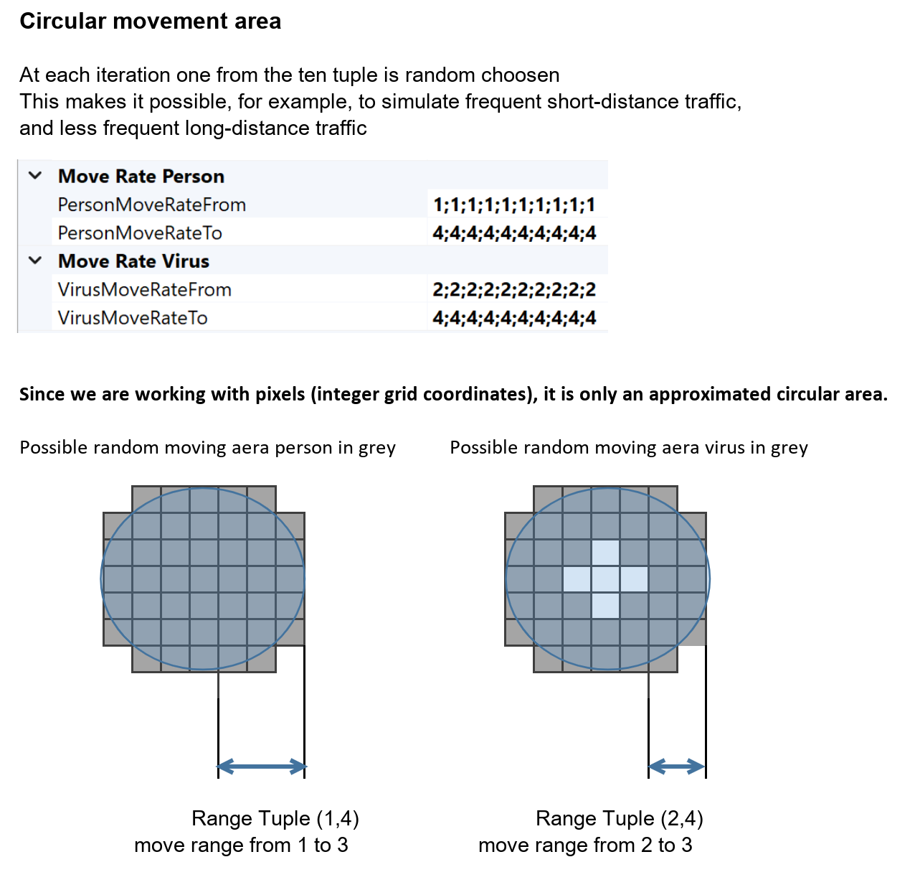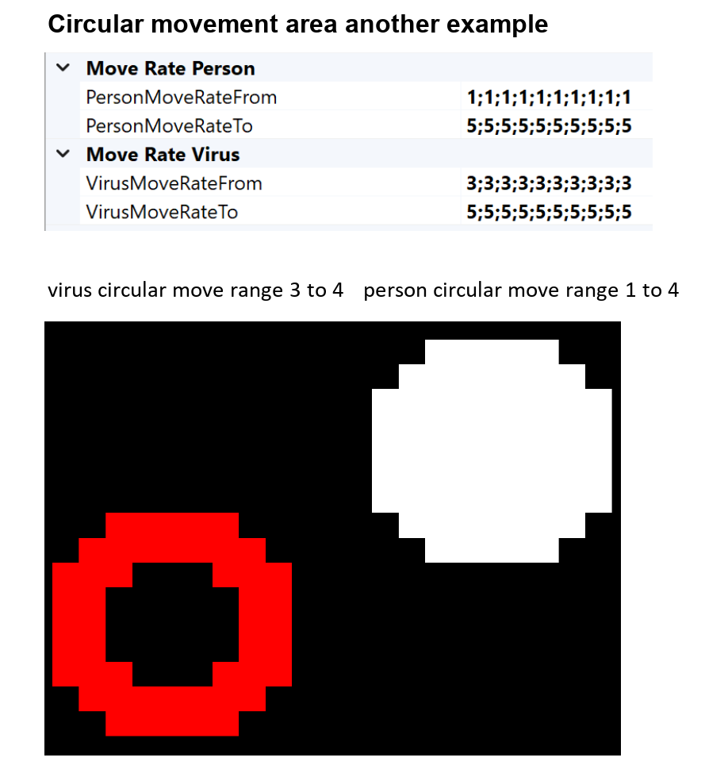

Creatures can move back to the home coordinate every x-th iteration if MoveHome is true. Where x is an integer.

green arrow move back home is true

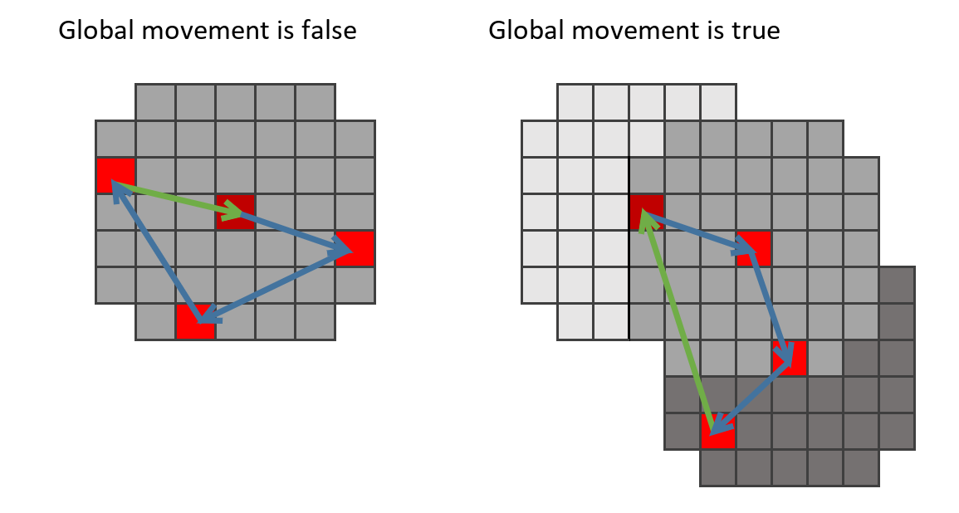

**Infection:**

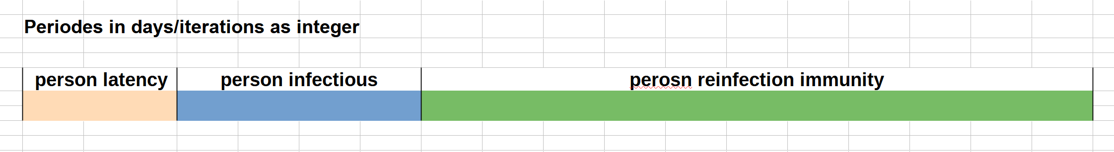

If one or more people on the same coordinate come into contact with a virus or another infectious person, everyone on the coordinate will be infected.

The **latency period** is a certain number of days/iterations  
  
The **infectious period** afterwards is again a certain number of days/iterations

During the infectious period, a fixed number of viruses are generated per person and per iteration (time) at the grid coordinate where the person is located at that time.

The **reinfection immunity** periode afterwards is again a certain number of days/iterations,

during this periode a person is immune, and cannot be reinfected again (immune system)

All viruses have an initially defined integer "lifespan" (age in iterations/days) during which they are infectious.

When this "lifetime" is reached, the virus is deleted from the grid.